Given a matrix and a target, return the number of non-empty submatrices that sum to target.

A submatrix x1, y1, x2, y2 is the set of all cells matrix[x][y] with x1 <= x <= x2 and y1 <= y <= y2.

Two submatrices (x1, y1, x2, y2) and (x1', y1', x2', y2') are different if they have some coordinate that is different: for example, if x1 != x1'.

**Example 1:**

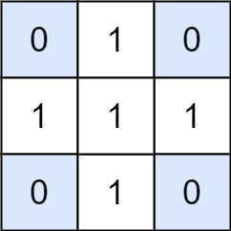

**Input:** matrix = [[0,1,0],[1,1,1],[0,1,0]], target = 0

**Output:** 4

**Explanation:** The four 1x1 submatrices that only contain 0.

**Example 2:**

**Input:** matrix = [[1,-1],[-1,1]], target = 0

**Output:** 5

**Explanation:** The two 1x2 submatrices, plus the two 2x1 submatrices, plus the 2x2 submatrix.

**Example 3:**

**Input:** matrix = [[904]], target = 0

**Output:** 0

**Constraints:**

* 1 <= matrix.length <= 100
* 1 <= matrix[0].length <= 100
* -1000 <= matrix[i] <= 1000
* -10^8 <= target <= 10^8